PENGENDALIAN KOROSI DENGAN MENGGUNAKAN ARUS
TANDINGAN

Tugas Akhir

Diajukan Untuk Memenuhi Persyaratan Dalam Menyelesaikan
Program S-1 Jurusan Teknik Mesin Fakultas Teknologi Industri
Universitas Bung Hatta

Oleh :

RIO FRENSISKO
1110017211044



UNIVERSITAS BUNG HATTA

FAKULTAS TEKNOLOGI INDUSTRI

PADANG

2015
DAFTAR ISI

Kata Pengantar.................................................................................................i
Abstract.............................................................................................................ii
Abstract..............................................................................................................iv
Daftar Isi...........................................................................................................vi
Daftar Tabel.....................................................................................................vi
Daftar Gambar................................................................................................viii
Daftar Grafik...................................................................................................xii
Daftar Lampiran.............................................................................................xiii

BAB I PENDAHULUAN
1.1. Latar Belakang ...............................................................................................1
1.2. Perumusan Masalah .......................................................................................2
1.3. Maksud Dan Tujuan Penilitian ......................................................................2
1.4. Batasan Masalah ............................................................................................2
1.5. Metodologi Penilitian ....................................................................................2
1.6. Sistematika Penulisan.....................................................................................4
BAB II TINJAUAN PUSTAKA
2.1. Korosi.............................................................................................................5
2.2. Faktor – faktor yang mempengaruhi korosi...................................................6
2.3. Jenis – jenis Korosi.........................................................................................7
2.3.1. Korosi Menyeluruh..........................................................................7
2.3.2. Korosi Galvanik...............................................................................8
2.3.3. Selective Leaching Corrosion.........................................................10
2.3.4. Korosi Celah....................................................................................12
2.3.5. Korosi Sumuran...............................................................................13
2.3.6. Intergranular Corrosion...................................................................14
2.3.7. SCC..................................................................................................16
2.3.8. Erosion Corrosion ..........................................................................17
2.4. Bilangan Oksidasi...........................................................................................19
2.5. Reaksi Reduksi Oksidasi (redok)...................................................................20
2.6. Larutan............................................................................................................21
2.7. Asam Dan Basa..............................................................................................22
2.8. Sifat – sifat Korosi Beberapa Bahan Logam..................................................23
2.8.1. Baja karbon murni dan baja karbon rendah.....................................23
2.8.2. Alumunium......................................................................................24
2.9. Pengendalian Korosi Dengan Proteksi Katodik.............................................24
2.9.1. Prinsip dari proteksi katodik............................................................25
2.10. Jenis – jenis Pengujian laju korosi ...............................................................26
2.10.1. Pengujian laboratorium .................................................................26
2.10.2. Pengujian lapangan........................................................................27
2.10.3. Standar pengujian laju korosi........................................................28
2.11. Kontrol Kondisi Pengujian Laboratorium....................................................28
2.11.1. Komposisi larutan..........................................................................28
2.11.2. Volume larutan uji.........................................................................29
2.11.3. Laju aliran arus dan tegangan........................................................29
BAB III METODOLOGI PENGUJIAN
3.1. Diagram Urutan Kerja....................................................................................30
3.2. Tahapan Pengujian..........................................................................................31
3.2.1. Persiapan benda uji..........................................................................31
3.2.2. Dimensi benda uji............................................................................31
3.2.3. Larutan.............................................................................................32
3.2.4. Perendaman benda uji......................................................................32
3.2.5. Perincian pengujian Benda uji.........................................................33
3.3. Peralatan Yang Digunakan.............................................................................34
3.3.1. Gelas ukur........................................................................................34
3.3.2. Kabel...............................................................................................34
3.3.3. PH meter.........................................................................................35
3.3.4. Timbangan digital...........................................................................36
3.3.5. Reactifier.........................................................................................37
3.4. Pengukuran Laju Korosi.................................................................................37
3.5. Rancangan Percobaan.....................................................................................38
3.6. Pengamatan.....................................................................................................39
BAB IV HASIL DAN PEMBAHASAN
4.1. Hasil Pengujian...............................................................................................40
4.2. Pembahasan....................................................................................................40
4.3. Tabel Hasil Pengujian.....................................................................................41
4.3.1. Grafik hasil pengujian air laut 100 ml + NaCl 100 gr.....................44
4.3.2. Grafik hasil pengujian air laut 100 ml + NaCl 200 gr.....................45
4.3.3. Grafik hasil pengujian air laut 100 ml + NaCl 300 gr.....................46
4.4. Analisa Data...................................................................................................47
BAB V KESIMPULAN DAN SARAN
5.1. Kesimpulan.....................................................................................................53
5.2. Saran...............................................................................................................54
DAFTAR PUSTAKA
LAMPIRAN

DAFTAR TABEL

Tabel 3.1. Perincian Benda Uji.............................................................................33
Tabel 4.1. Hasil Pengujian 8 jam..........................................................................41
Tabel 4.2. Hasil Pengujian 16 jam........................................................................42
Tabel 4.3. Hasil Pengujian 24 jam........................................................................43

DAFTAR GRAFIK

Grafik 4.3.1. Grafik Larutan air laut 100 ml + 100 gr NaCl................................44
Grafik 4.3.2. Grafik Larutan air laut 100 ml + 200 gr NaCl................................45
Grafik 4.3.3. Grafik Larutan air laut 100 ml + 300 gr NaCl................................46

DAFTAR GAMBAR

Gambar 1.1. Skema Metodologi Penilitian..........................................................4
Gambar 2.1. Konvensi Kelistrikan......................................................................5
Gambar 2.2. Skema Faktor Yang Mempengaruhi Korosi..................................6
Gambar 2.3. Korosi menyeluruh..........................................................................7
Gambar 2.4.Korosi Galvanik................................................................................8
Gambar 2.5. Mekanisme Korosi Galvanik...........................................................9
Gambar 2.6. Selective Leaching Corrosion Pada Pipa.........................................10
Gambar 2.7. Mekanisme Selective.......................................................................11
Gambar 2.8. Korosi Celah....................................................................................12
Gambar 2.9. Mekanisme Korosi Celah................................................................12
Gambar 2.10. Korosi Sumuran.............................................................................13
Gambar 2.11. Mekanisme Pitting Corrosion........................................................14
Gambar 2.12 Korosi Batas Butir Pada Pipa..........................................................14
Gambar 2.13. Mekanisme Butir Batas Butir........................................................15
Gambar 2.14. Korosi SCC....................................................................................16
Gambar 2.15. Mekanisme Korosi SCC................................................................17
Gambar 2.16. Korosi Erosi...................................................................................17
Gambar 2.17. Mekanisme Korosi Erosi...............................................................18
Gambar 3.1. Diagram Urutan Kerja.....................................................................30
Gambar 3.2. Benda Uji.........................................................................................31
Gambar 3.3. Perendaman Benda Uji.....................................................................32
Gambar 3.4 Kabel Penghubung............................................................................34
Gambar 3.5. PH Meter..........................................................................................35
Gambar 3.6. Timbangan Digital...........................................................................36
Gambar 3.7. Reactifier..........................................................................................37
Gambar 3.8. Proses Pengendalian Korosi Dengan Arus Tandingan....................38

DAFTAR LAMPIRAN

Lampiran A. Benda Uji
Lampiran B. Penguian Berlangsung
Lampiran C. Anoda Terkonsumsi
Lampiran D. Reactifier
Lampiran E. Neraca Analitik
Lampiran F. Saat Melakukan Pengujian

DAFTAR PUSTAKA

American Society For Testing and Material. 1999,G1 Practice For preparing,
Cleaning, and Evaluating Corosian Test Specimens, ASTM A36 Vol.
03,02, ASTM Society.
A. Jones, Denny. 1995. Principle and Prevention of coorosion.Macmillan
Publiching Company, New York.
Djafrie Sriati, Ilmu teknologi bahan, Erlangga, Jakarta,1992.
Jenis Baja ASTM A 36, http//www.onealsteel.com/carbon-steel-plate-a36.html.
Laju Korosi, http;//sainsforhuman.blogspot co.id/2013/07/apa-itu-korosi
-penyebab-dan cara.
html#sthash.09mTw Mzi dput.
Laju Korosi, http://kapal-cargo.blogspot.com/2011/05/korosi-kapal-baja.html .
Profil Baja ASTM, http;//www.bumibajasakti.com/index.php/produk/besibaja/
baja Astm a36, di akses tanggal 7 desember 2015 jam 01.00.
Supriyanto, 2007, Pengaruh Konsentrasi Larutan Terhadap laju korosi pada
baja karbon rendah, Universitas Muhammadiyah Surakarta.
Trothwen,KR.Jhon anamberalih,Korosi untuk mahasiswa dan rekayasa,Gramedia
Pustaka Utama,Jakarta,1992.

LAMPIRAN

Lampiran A
Gambar Benda Uji

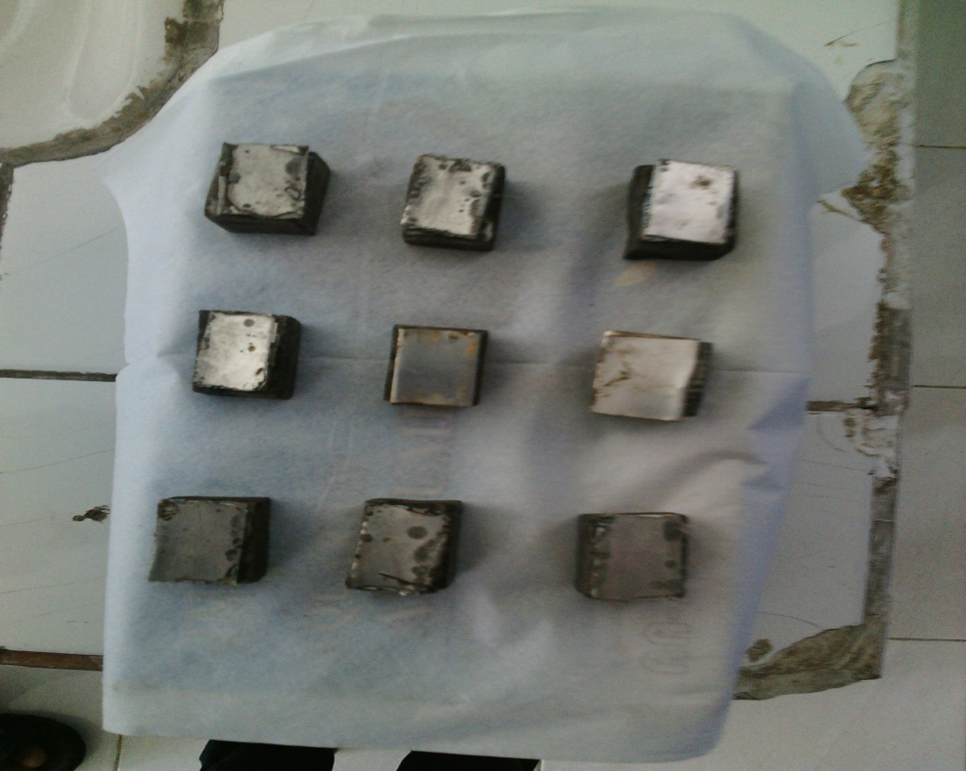

Lampiran B
Gambar Pengujian Berlangsung
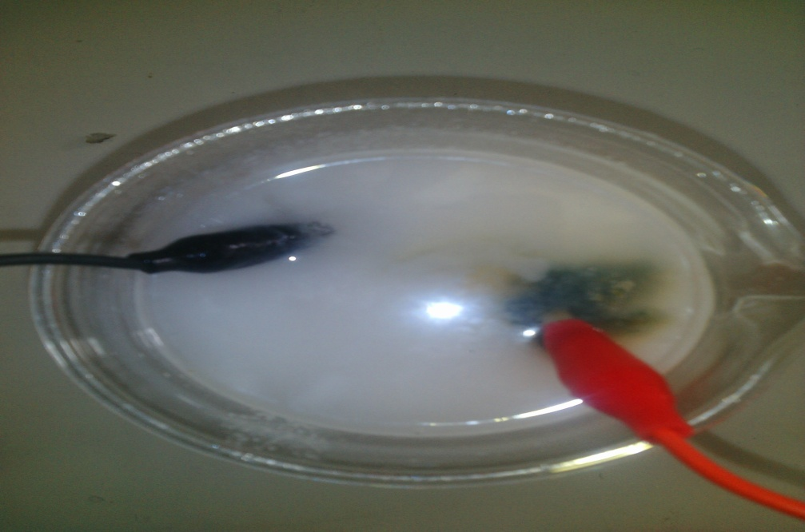
Lampiran C
Gambar Anoda
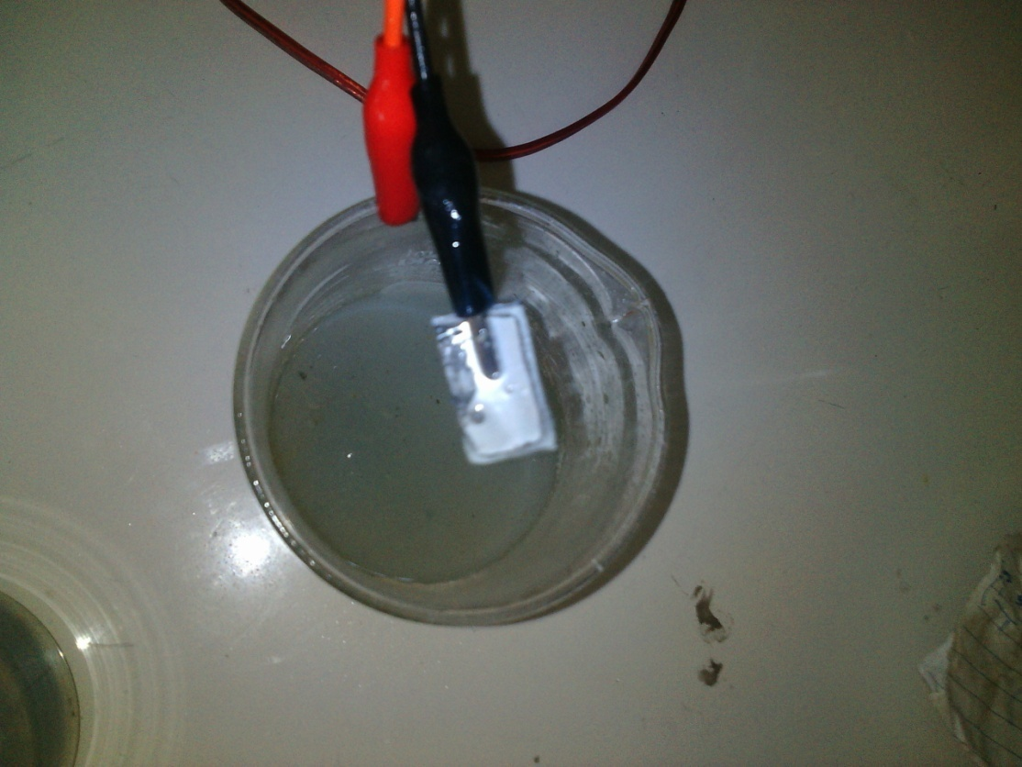

Lampiran D
Gambar Reactifier
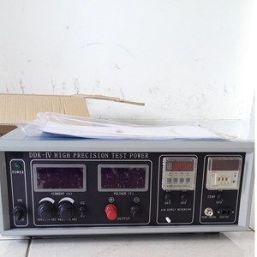
Lampiran E
Gambar Timbangan Neraca Analitik
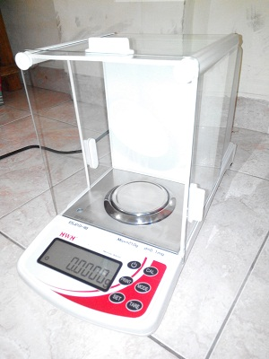
Lampiran F
Gambar Saat Melakukan Pengujian
